# Hierarchy:

An important feature of Delphi is the use of third-party libraries. This can be simple libraries with often used procedures and functions to more sophisticated visual and nonvisual objects.

To be able to use the more sophisticated objects you need to install them in your IDE by the means of packages.

Even then the source files of these packages should be available to the projects by providing a search path.

This search path can be provided by 3 different methods.

1. Adding the search path to your IDE and doing so, be available for all your projects.
2. Adding them to your project like: h:\delphi_10\Forms;h:\delphi_10\excmagic
3. Adding them to you project with a relative path like: ..\Forms;..\excmagic

We prefer method 3. Because it is installation and drive letter independent.

As a result, it is important that all the developers use the same folder hierarchy, so that the relative paths are pointing to the correct sources.

Currently we use this hierarchy located on the developers personal H: drive, which is on a server that is backuped daily:

Delphi_10 --+-- Internet --+-- AdhocXML

| |

| +-- Available

|

+-- Websrv --+-- B2B_SAP

| |

| +-- TotAvail

|

+-- Forms

Delphi_5 --+-- Websrv --+-- TecCom

| |

| +-- TyreData

|

+-- Forms

The projects are divided by Delphi version then type of application, sometimes there is even a third level.

Curl test scripts are normally on the local c: drive in the curl installation folder.

On Internet/Websrv level the different projects are mixed, which is not very suitable to get a good overview of projects that belong together.

I would like the projects that belong together to be grouped together on a higher level.

RAD --+-- eCommerce Handler --+-- B2B_SAP --+-- Delphi_10

| | |

| | +-- Curl

| | |

| | +-- Docs

| |

| +-- TecCom --+-- Delphi_5

| |

| +-- TyreData --+-- Delphi_5

| |

| +-- AdhocXML --+-- Delphi_10

| |

| +-- TotAvail --+-- Delphi_10

|

+-- Lib --+-- Forms --+-- Delphi_10

| |

| +-- Delphi_5

|

+-- OXml

The advantage is that projects are logically grouped together. This hierarchy can be used is GitLab very easily too:

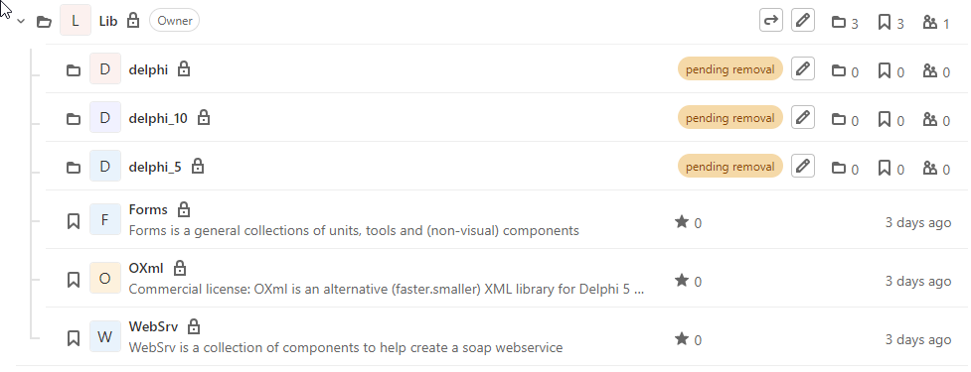

Example B2B_SAP:

RAD --+-- eCommerce Handler --+-- B2B_SAP --+-- Delphi_10

| |

+-- Curl

|

+-- Docs

The sources should be in a Delphi_5 or Delphi_10 folder.

I have created (altered) a .gitignore file designed for Delphi, that should be in the project folder too.

There is a documentation folder and especially for SAP interfaces a Curl folder with test scripts.

I would like a readme.md file in the project folder too:

# B2B

Webservice that acts as an interface between the B2B site and SAP:

Type: ISAPI

Location: \\Dealer\d$\Services

Maintainer: Wilfred Geerlings

Info:

B2B.dproj: Project file for creating the ISAPI DLL

B2B_APPL.dproj: Project file for the standalone testing and debugging application

B2B_ProjectGroup.groupproj: Project group for both projects

Libraries used:

OXml

WebSrv in Forms

With some information about the project.

# Work in progress, not complete, probably going to change a lot.

Tools:

* Git: https://git-scm.com/download/win
* TortoiseGit: <https://tortoisegit.org/download/>
  + https://download.tortoisegit.org/tgit/2.12.0.0/TortoiseGit-2.12.0.0-64bit.msi
* SourceTree: https://sourcetreeapp.com/?v=win

Uitleg wilfred:

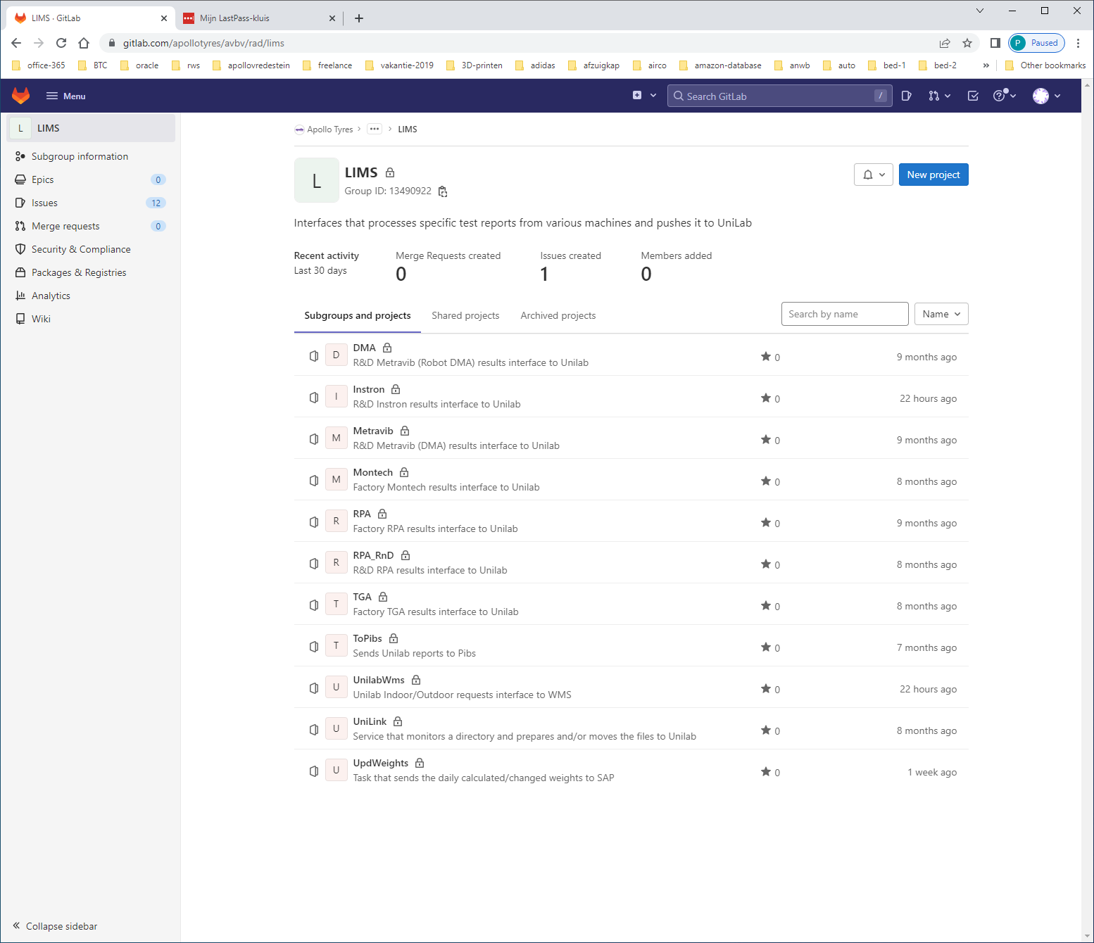

CLONE with SSH: [git@gitlab.com:apollotyres/avbv/rad/lims/updweights.git](mailto:git@gitlab.com:apollotyres/avbv/rad/lims/updweights.git)  
CLONE WITH https: <https://gitlab.com/apollotyres/avbv/rad/lims/updweights.git>

Niet in combinatie met forcepoint, met https de connectie push/pull gebruiken.

USER IN NON-FORCE-POINT USER

Ssh heeft wilfred niet voor elkaar kunnen krijgen.

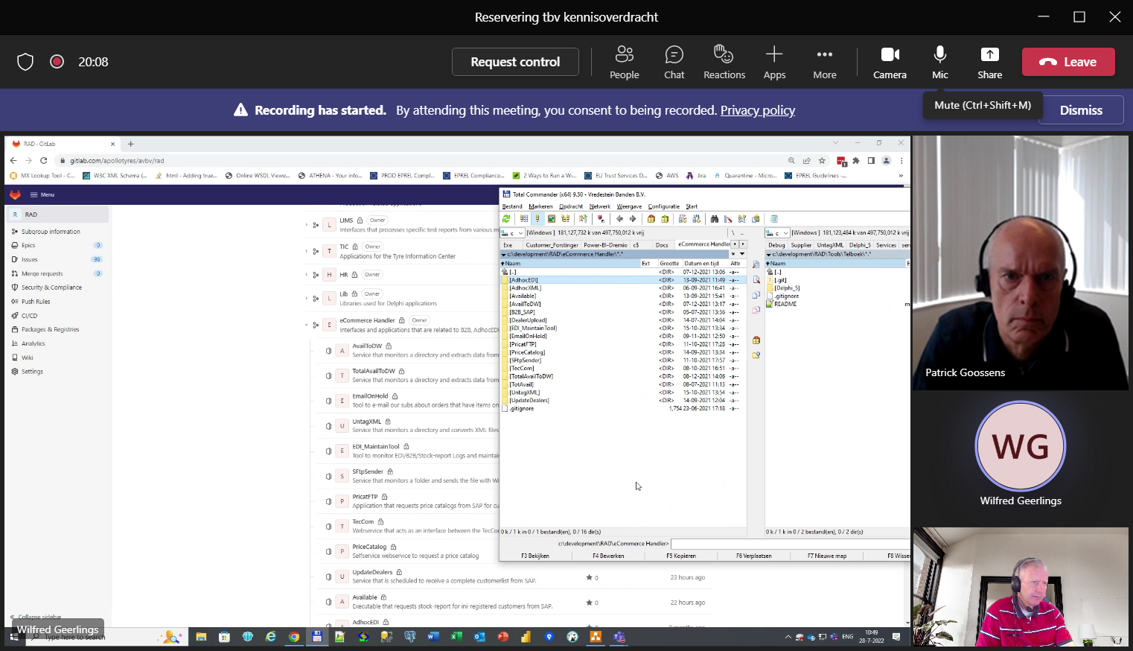

Lims

Wordt eigenlijk alleen op de MASTER gewerkt, geen branches !!!